Information to provide news organizations about the 2022 Babies With Books read-a-thon
BWB Read-a-thon Highlights
This September, in honor of National Literacy Month, more than 170 hospitals across the US and in 4 other countries (Canada, the UK, Ethiopia, and the United Arab Emirates) are registered to come together to promote reading to babies in the Neonatal Intensive Care Unit (NICU), the hospital unit that cares for sick babies and their families.

The annual Babies With Books (BWB) NICU read-a-thon is a friendly, international reading competition between both families and NICUs. The read-a-thon works to encourage family reading, support infants and families, and build NICU morale especially during the isolating time of COVID-19. This read-a-thon is modeled after last September’s event that engaged 105 NICUs, yielded >6,000 reading sessions, and resulted in 97% of NICUs reporting that the event encouraged them to start or expand their reading program.

See NICUs registered for the read-a-thon here: https://www.google.com/maps/d/edit?mid=14ZnTFeZXrE-YWEe5PyrFn-ir1kc5NpQ&usp=sharing. For the full list of registered NICUs, see the bottom of this document and visit babieswithbooks.org/readathon.
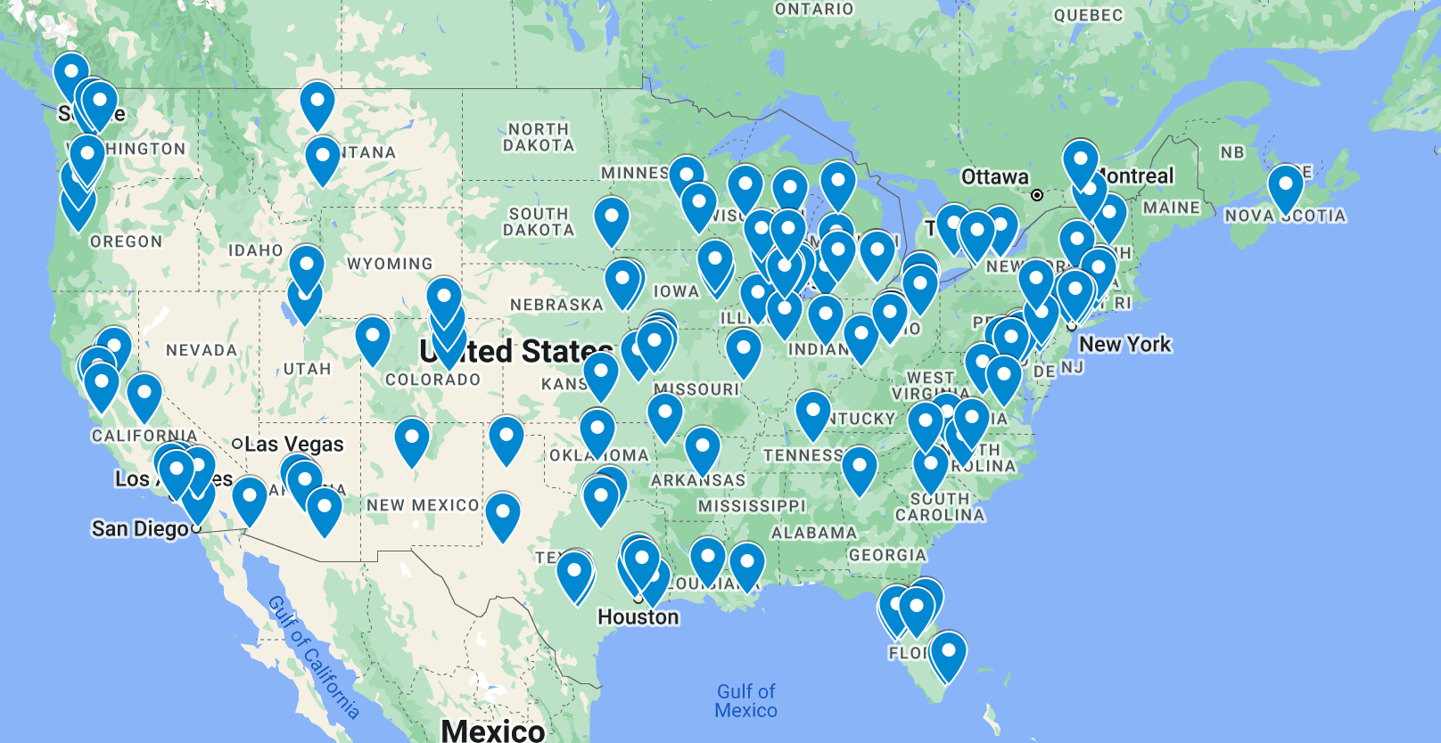
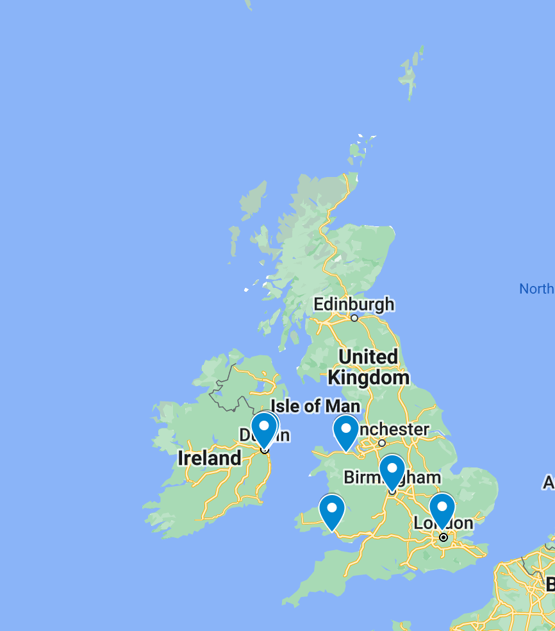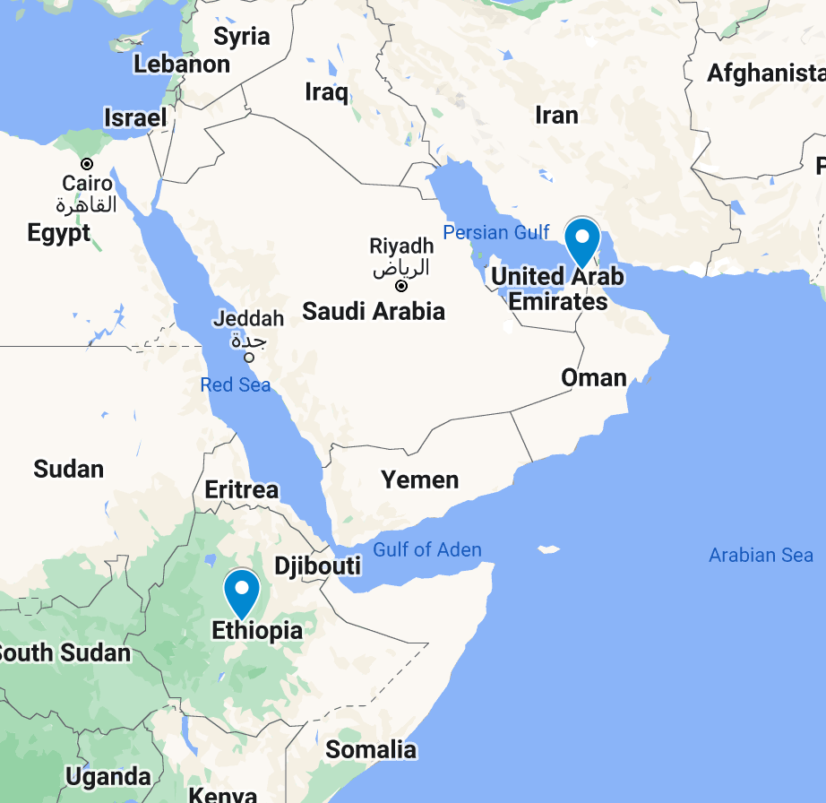

Feedback from September 2020 read-a-thon:
- “Families rallied around the chance to start reading with their babies as a way to bond.” - NICU Nurse
- "I loved it! And the babies seemed to enjoy it, too. I noticed they became calm, attentive, and had more regular heart rates and breathing rates when being read to." - NICU Speech Therapist
- ​"I'm so proud of our entire NICU team for participating in this amazing opportunity to help bring awareness to a crucial and often under-recognized topic." - NICU Medical Director
- ​“This experience reminds me why I love my job." - Chief Nursing Officer
Why read to babies in the NICU?
NICU babies are at high risk of poor neurodevelopmental outcomes due to prematurity, critical illness, prolonged hospitalization, low socioeconomic status, and family emotional and economic stressors associated with hospitalization in the Neonatal Intensive Care Unit (NICU). Care in single-patient room NICUs can compound the issues of sensory deprivation and contribute to speech and language deficits in NICU graduates. According to the American Academy of Pediatrics, reading with babies creates and strengthens neural connections that “promote … social-emotional development…and language and literacy skills during this critical period of early brain and child development.”

Providing parents and other caregivers books and encouraging them to read with infants in the NICU provides an important route for increasing infants’ speech and language interactions and supports bonding and family involvement with their infants’ care in the NICU. Studies have demonstrated that providing books to NICU families increases family reading in the NICU. Studies have also suggested that increased reading before kindergarten may result in increased brain development and that book ownership motivates reading.

Babies With Books information:
Website: babieswithbooks.org
Read-a-thon website: babieswithbooks.org/readathon

Babies With Books contact:
Benjamin Olshin
Founder and Executive Director, Babies With Books
Email: benjamin.olshin@babieswithbooks.org

Note: information sourced from babieswithbooks.org

List of 2022 read-a-thon registrants (n=177):

- Abrazo Arrowhead Hospital  - Advent Health Shawnee Mission  - Advocate Children's Hospital in Oak Lawn  - Advocate Children's Hospital in Park Ridge  - Advocate Good Samaritan Hospital  - Advocate Illinois Masonic Medical Center  - Atrium Health Wake Forest Baptist, Brenner Children's Hospital  - Banner Children's at Banner Desert Medical Center  - Banner Thunderbird Medical Center  - Banner University Medical Center Tucson  - Barnet Hospital in the UK  - Baylor Scott and White Medical Center of Frisco  - Beacon Children's Hospital  - Bellin Health Hospital  - Benefis Health System  - Benioff Children's Hospital  - Birmingham Women’s Hospital  - Boston Medical Center  - Bozeman Health  - Bronson Children's Hospital  - BSA Health System  - Cardinal Glennon Children's Hospital  - Carle Foundation Hospital  - Catawba Valley Medical Center  - Cedars-Sinai Medical Center  - Chandler Regional Medical Center  - CHI at Temple Street in Ireland  - CHI Crumlin in the UK  - Children's Hospital Colorado in Aurora  - Children's Hospital Colorado in Colorado Springs  - Children's Hospital of New Orleans  - Children's Mercy Hospital  - Children’s Wisconsin  - CHOP at Penn Medicine Chester County Hospital  - Christiana Care  - CHU Sainte-Justine in Canada  - Cincinnati Children's Hospital Medical Center  - Cleveland Clinic Akron General  - Cleveland Clinic Hillcrest Hospital  - Connecticut Children's at UConn Health  - Connecticut Children's Medical Center  - Cook Children's Medical Center  - Cooperman Barnabas Medical Center  - Dartmouth Health Children's Hospital  - Edward Hospital  - Flushing Hospital Medical Center  - Geisinger Wyoming Valley  - George Washington University Hospital  - Glan Clwyd Hospital in the UK  - Glangwili Hospital  - Good Samaritan Hospital  - Greater Baltimore Medical Center  - HCA Houston Healthcare Conroe  - HCA Houston Healthcare Kingwood  - HCA Houston Healthcare West  - Hospital of Central Connecticut  - Houston Methodist The Woodlands  - Houston Methodist Willowbrook Hospital  - Huntington Memorial Hospital  - Inova Loudoun  - Intermountain Medical Center  - IWK Health in Canada  - Jewish General Hospital  - Joe DiMaggio Children’s Hospital  - John Muir Medical Center Walnut Creek  - John Peter Smith Hospital  - John R. Oishei Children's Hospital  - Johns Hopkins Bayview Medical Center  - Kaiser Permanente Santa Clara Medical Center  - Kapiolani Medical Center for Women and Children  - Legacy Salmon Creek Medical Center  - Liberty Hospital  - Logan Regional Hospital  - Maria Fareri Children's Hospital  - Marshfield Children's Hospital  - Mayo Clinic  - McMaster Children's Hospital in Canada  - Mease Countryside Hospital  - Memorial Hermann The Woodlands  - Memorial Hospital Miramar  - Mercy San Juan Medical Center  - Mercyhealth Javon Bea Riverside  - Methodist Children’s Hospital  - Methodist Women's Hospital  - Midland Health - Midland Memorial Hospital  - Millard Fillmore Suburban Hospital  - Miller Children's & Women's Hospital Long Beach  - Mission Trail Baptist Hospital  - Monroe Carell, Jr. Children's Hospital  - Montefiore Medical Center | - Morgan Stanley Children's Hospital/Columbia University Medical Center  - Morton Plant Hospital  - Mott Children's Hospital  - Mount Carmel St. Ann's Hospital  - Munson Medical Center  - National Maternity Hospital in Ireland  - Nationwide Children's Hospital  - Nationwide Children's Hospital at Riverside Methodist Hospital  - Nationwide Children's Hospital at The Ohio State University Wexner Medical Center  - Nationwide Children's NICU at Grant  - Nebraska Medicine Nebraska Medical Center  - Nemours Children's Hospital  - North Central Baptist Hospital  - North Shore University Hospital  - NYU Langone Hospital—Long Island  - Oklahoma Children's Hospital OU Health  - OSF Saint Francis Children's Hospital of Illinois  - Our Lady of Lourdes Women’s and Children’s Hospital  - PeaceHealth Sacred Heart RiverBend Medical Center  - Peyton Manning Children's Hospital  - Pomona Valley Hospital Medical Center  - Presbyterian Hospital  - Prisma Health Richland Hospital  - Providence Portland Medical Center  - Rady Children Hospital of San Diego  - Randall Children's Hospital  - Regions Hospital  - Riverside University Hospital System  - Rochester General Hospital  - Ronald Reagan UCLA Medical Center  - Rose Medical Center  - Rush Copley Medical Center  - Salem Health  - San Francisco General Hospital  - Sanford Children's Hospital  - Santa Clara Valley Medical Center  - Sharp Mary Birch Hospital for Women and Newborns  - Sheikh Khalifa Medical City in the United Arab Emirates  - Singleton Hospital in the UK  - St Joseph Medical Center  - St Joseph Women's Hospital  - St. Joseph’s Hospital and Medical Center  - St. Louis Children’s Hospital  - St. Luke's Kansas City  - St. Luke's South Hospital  - St. Luke’s Baptist Hospital  - St. Luke’s East  - St. Mary's Medical Center  - St. Paul's Hospital Millennium Medical College in Ethiopia  - St. Peter's Hospital  - Swedish Providence Hospital Issaquah  - The Children's Hospital at Providence in Anchorage  - The Children's Hospital of San Antonio  - The Clarke Neonatal Intensive Care Unit at FirstHealth Moore Regional Hospital  - Trinity Health Ann Arbor  - Trinity Health St. Mary's  - UCHealth - Poudre Valley Hospital  - UCSF Benioff Children's Hospital Oakland  - UH Rainbow Babies and Children's Hopsital  - UNC Health  - UnityPoint Health - Meriter Hospital  - UnityPoint Health - St. Luke's Hospital  - University Health Truman Medical Center  - University of Arkansas for Medical Sciences  - University of California Davis Children's Hospital  - University of California, Irvine Medical Center  - University of Illinois Hospital and Health Sciences System  - University of Iowa Stead Family Children's Hospital  - University of Texas Medical Branch  - University of Vermont Medical Center  - University of Virginia Children's Hospital  - University of Washington Medical Center  - UPMC Harrisburg  - UR Medicine Golisano Children's Hospital  - UW Health SwedishAmerican Hospital  - Valley Childrens Hospital  - Valley Medical Center  - Victoria General Hospital in Canada  - Virginia Commonwealth University Healthcare System  - Walter Reed National Military Medical Center  - Washington Regional Medical Center  - Wellstar Kennestone Hospital  - Wesley Medical Center  - White Plains Hospital  - Winter Haven Women’s Hospital  - Yale New Haven Hospital  - Yuma Regional Medical Center

